Kendriya Bhandar : Consumer Division
New Delhi
KB/l/C/ GST/2017 May 30, 2017

CIRCULAR
As you are aware (Goods & Services Tax) GST is likely to be implemented by Govt, of India shortly. You are, therefore, requested to submit the following details as per the format at the earliest:-
Name of the Firm | Vendor  Name | KB item code | Old VAT Rate | GST Regn. NO. & Date | PAN No. of the Firm | HSN  Code | HSN  Category | GST
 |  |  |  |  |  |  |  | SGST | CGST | IGST | Total

Please treat this as URGENT and accord priority.
Regards,
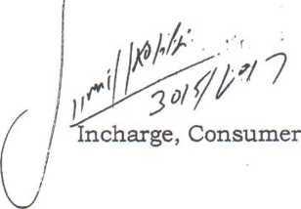
To:
- All Registered suppliers

Copy to:
- AGM (C)
- PS to MD
- Office Copy

